**DESSERT SHOP**

Project Report

Duration: 12th – 17th January, 2026

Developed by: P. Manimegalai

# Executive Summary:

The **Dessert Shop Website** is a modern, user-friendly e-commerce platform designed to enhance the online dessert shopping experience. Users can explore a variety of desserts, view product details, add favorites to a wishlist, and interact with an intuitive shopping cart.

The website emphasizes visual appeal, smooth navigation, and interactive features that improve user engagement. Key functionalities include category browsing, featured products, promotional offers, FAQ section, user authentication popups, and responsive layouts suitable for all devices. The project demonstrates adherence to UI/UX best practices, clean code structure, and scalability for future backend integration.

# Project Team

|  |  |
| --- | --- |
| **Role** | **Name** |
| Project Manager | Alagu Mari |
| Designer | Malathy |
| Developer | Manimegalai |
| Tester | Yogavarshini |

# Technology Stack

|  |  |
| --- | --- |
| **Frontend** | **Server** |
| HTML, CSS, JavaScript | GitHub Pages |

# Project Objectives:

* Design an attractive and responsive dessert shop website
* Enable users to browse desserts by categories easily
* Implement wishlist and cart interactions
* Ensure smooth navigation and modern UI/UX design
* Build a scalable frontend ready for future backend integration
* Include promotional offers and FAQ for better user support

# Project Scope

# Product browsing with images, prices, and ratings

# Category-wise dessert organization

# Wishlist functionality for saving favorite items

# Shopping cart for selected desserts

# User authentication (Login/Signup modals)

# Promotional banners and discount offers

# FAQ section for user guidance

# Footer with contact info and social media links

# Responsive design for desktop, tablet, and mobile

# Admin panel (future scope for content management)

# Project Modules

|  |  |
| --- | --- |
| Home Page | Entry point with banners, featured desserts, and categories |
| Category Module | Displays dessert categories for quick access |
| Product-Listing Module | Shows desserts with images, ratings, price, and discounts |
| Wishlist Module | Allows users to save favorite desserts |
| Cart Module | Enables adding desserts to the shopping cart |
| User Authentication | Login and signup modal popups |
| FAQ Module | Provides answers to common customer questions |
| Footer & Social Links | Shows contact info, navigation links, and social media |
| Admin Panel (Future) | Backend content management system |

# Key Highlights

* Fully responsive layout for all devices
* Modern and clean user interface
* Interactive wishlist and shopping cart icons
* Modal-based login/signup system
* FAQ accordion for better user experience
* Consistent color palette and typography
* Optimized performance and fast loading
* Scalable frontend architecture for future enhancements

# Project Code

Below is an example snippet from the home.html structure:

<!DOCTYPE html>

<html lang="en">

<head>

  <meta charset="UTF-8">

  <meta name="viewport" content="width=device-width, initial-scale=1.0">

  <title>The Dessert House</title>

  <!-- Inria Sans Font -->

  <link href="https://fonts.googleapis.com/css2?family=Inria+Sans:wght@400;700&display=swap" rel="stylesheet">

  <!-- Font Awesome -->

  <link rel="stylesheet" href="https://cdnjs.cloudflare.com/ajax/libs/font-awesome/6.5.1/css/all.min.css">

  <link rel="stylesheet" href="css/aboutus.css">

</head>

<body>

  <header>

    <div class="navbar">

      <!-- LOGO -->

      <div class="logo">

        <img src="images/logo.png" alt="Dessert Logo">

        <span>The Dessert House</span>

      </div>

      <!-- MENU -->

      <nav class="nav-links">

        <a href="aboutus.html">About Us</a>

        <!-- Desserts Dropdown -->

        <div class="dropdown">

          <a href="javascript:void(0)" onclick="toggleDropdown()">Desserts</a>

          <div class="dropdown-menu" id="dessertMenu">

            <a href="alldesert.html">All Desserts</a>

            <a href="pastry.html">Pastry</a>

            <a href="brownies.html">Brownies</a>

            <a href="tarts.html">Tart</a>

            <a href="teacake.html">Tea Cake</a>

            <a href="cupcake.html">Cup Cake</a>

            <a href="jarcake.html">Jar Cake</a>

            <a href="combo.html">Combos</a>

          </div>

        </div>

        <a href="contact.html">Contact</a>

      </nav>

      <!-- RIGHT -->

      <div class="nav-right">

        <div class="search-box">

          <input type="text" placeholder="Search">

          <i class="fa-solid fa-magnifying-glass"></i>

        </div>

        <button class="login-btn">Log In / Sign Up</button>

      </div>

    </div>

  </header>

  <!-- LOGIN POPUP -->

  <div class="overlay" id="loginOverlay">

    <div class="login-modal">

      <span class="close-btn" onclick="closeLogin()">✕</span>

      <h2>Login / Sign Up</h2>

      <input type="text" id="loginInput" placeholder="Enter Email ID">

      <p class="switch" onclick="toggleLoginMode()">With Mobile</p>

      <button class="otp-btn" onclick="sendOTP()">Get OTP →</button>

      <input type="text" id="otpInput" placeholder="Enter OTP" class="hidden"><br>

      <button class="otp-btn hidden" id="verifyBtn" onclick="verifyOTP()">Verify OTP</button>

      <p class="terms">

        By continuing I agree to The Dessert House’s Terms and Conditions and Privacy Policy.

      </p>

    </div>

  </div>

  <section class="about-section">

    <h2>About Us</h2>

    <h3>Food of The Gods, Freshly Baked!</h3>

    <p class="sub-text">

      Since 2024, we've been serving our guests the best quality treats,<br>

      traditionally made and presented with care.

    </p>

    <div class="about-grid">

      <!-- LEFT -->

      <div>

        <div class="info-block" style="margin-bottom:60px;">

          <h4>AUTHENTIC RECIPES</h4>

          <p>

            Our products are based on<br>

            traditional home-style recipes<br>

            using fresh ingredients.

          </p>

        </div>

        <div class="info-block">

          <h4>BAKED WITH LOVE</h4>

          <p>

            Our passion for baking is poured into<br>

            every recipe, serving smiles on a<br>

            plate everyday.

          </p>

        </div>

      </div>

      <!-- CENTER IMAGE -->

      <div class="center-img">

        <img src="images/aboutus.png" alt="Dessert House Illustration">

      </div>

      <!-- RIGHT -->

      <div>

        <div class="info-block" style="margin-bottom:60px;">

          <h4>COMMITTED TO QUALITY</h4>

          <p>

            From our ingredients to our<br>

            kitchen operations and guest services,<br>

            we always prioritize quality.

          </p>

        </div>

        <div class="info-block">

          <h4>HONESTLY PRICED</h4>

          <p>

            We constantly strive to offer the best<br>

            products at the right prices.

          </p>

        </div>

      </div>

    </div>

    <!-- BOTTOM DESCRIPTION -->

    <div class="bottom-text">

      <p>

        "The dessert house" would be a dedicated establishment for sweet foods and indulgent range of offerings that

        include brownies, cakes, desserts, chocolates, breads, and savouries.

      </p>

      <br>

      <p>

        From our humble beginnings in 2024, when the first The dessert house pastry store opened its doors at the place

        of Karaikudi, Tamil Nadu, India, we've grown to become a Pan-India chain of patisseries with stores in over 10

        cities.

      </p>

      <br>

      <p>

        Our mission is to spread happiness by serving smiles on a plate, and this journey continues as we open The

        dessert house patisseries across the country.

      </p>

    </div>

  </section>

  <section class="brand-wrapper">

    <div class="brand-content">

      <!-- LEFT -->

      <div class="brand-text">

        <p><strong>We as a brand believe in the power of wishes.</strong></p>

        <p class="highlight">

          Remember the days when you believed anything was possible?

        </p>

        <p>

          When dreams felt like they were within reach? We want to bring that sense of wonder back to your life.

        </p>

        <p>

          With every cake we create, we aim to spark joy and remind you that dreams do come true.

        </p>

        <p>

          At the heart of our journey is constant innovation. Our in-house R & D centre helps us discover new flavours,

          reimagine classic desserts, and craft experiences that delight with every bite.

        </p>

        <p>

          This commitment to creativity and quality has not only won hearts but also earned us industry recognition,

          including winning the Swiggy Award for Best Dessert Brand a milestone that sweetly affirms our mission.

        </p>

      </div>

      <!-- RIGHT -->

      <div class="brand-image">

        <img src="images/about2.png" alt="Dessert Cups">

      </div>

    </div>

    <!-- CURVE -->

    <div class="award-wave">

      <svg viewBox="0 0 1440 120" preserveAspectRatio="none">

        <path d="

      M0,40

      C90,0 90,0 180,40

      C270,80 270,80 360,40

      C450,0 450,0 540,40

      C630,80 630,80 720,40

      C810,0 810,0 900,40

      C990,80 990,80 1080,40

      C1170,0 1170,0 1260,40

      C1350,80 1350,80 1440,40

      L1440,120

      L0,120

      Z" fill="#D72D52" />

      </svg>

      <div class="award-text">

        Swiggy Award for Best Dessert Brand

      </div>

    </div>

  </section>

  <!-- STATS -->

  <div class="stats">

    <div class="stat">

      <i class="fa-solid fa-chef-hat"></i>

      <p>Founded in 2024</p>

    </div>

    <div class="stat light">

      <i class="fa-solid fa-location-dot"></i>

      <p>10 Cities</p>

    </div>

    <div class="stat">

      <i class="fa-solid fa-gift"></i>

      <p>20+ Unique Desserts</p>

    </div>

  </div>

  <footer>

    <!-- ✅ UPWARD CURVE -->

    <div class="footer-wave">

      <svg viewBox="0 0 1440 120" preserveAspectRatio="none">

        <path d="

      M0,70

      C72,10 72,10 144,70

      C216,130 216,130 288,70

      C360,10 360,10 432,70

      C504,130 504,130 576,70

      C648,10 648,10 720,70

      C792,130 792,130 864,70

      C936,10 936,10 1008,70

      C1080,130 1080,130 1152,70

      C1224,10 1224,10 1296,70

      C1368,130 1368,130 1440,70

      L1440,0

      L0,0

      Z" fill="#F8EBEB" />

      </svg>

    </div>

    <!-- QUICK LINKS TITLE (CENTERED) -->

    <div class="footer-column quick-links-title">

      <h3>Quick Links</h3>

    </div>

    <div class="footer-container">

      <div class="footer-column">

        <div class="footer-logo">

          <img src="images/logo.png" alt="Dessert House Logo">

          <h2>The Dessert House</h2>

        </div>

      </div>

      <div class="footer-column footer-links">

        <a href="aboutus.html">About Us</a>

        <a href="alldesert.html">Desserts</a>

        <a href="contact.html">Contact</a>

        <a href="blogs.html">Blogs</a>

      </div>

      <div class="footer-column footer-links">

        <a href="faq.html">FAQ</a>

        <a href="privacy.html">Privacy Policy</a>

        <a href="terms.html">Terms and Conditions</a>

        <a href="refund.html">Refund Policy</a>

      </div>

      <div class="footer-column">

        <div class="contact-info">

          <div><i class="fa-solid fa-phone"></i> +91 987 654 3210</div>

          <div><i class="fa-solid fa-envelope"></i> Contact@thedesserthouse.in</div>

        </div>

        <div class="social-icons">

          <i class="fa-brands fa-youtube"></i>

          <i class="fa-brands fa-facebook"></i>

          <i class="fa-brands fa-instagram"></i>

        </div>

      </div>

    </div>

    <div class="footer-bottom">

      2024@thedesserthousein

    </div>

    </div>

  </footer>

  <script src="js/script.js"></script>

</body>

</html>

Project Screenshots

Sample screenshots from the Grocery Website :

1.Aboutus page:

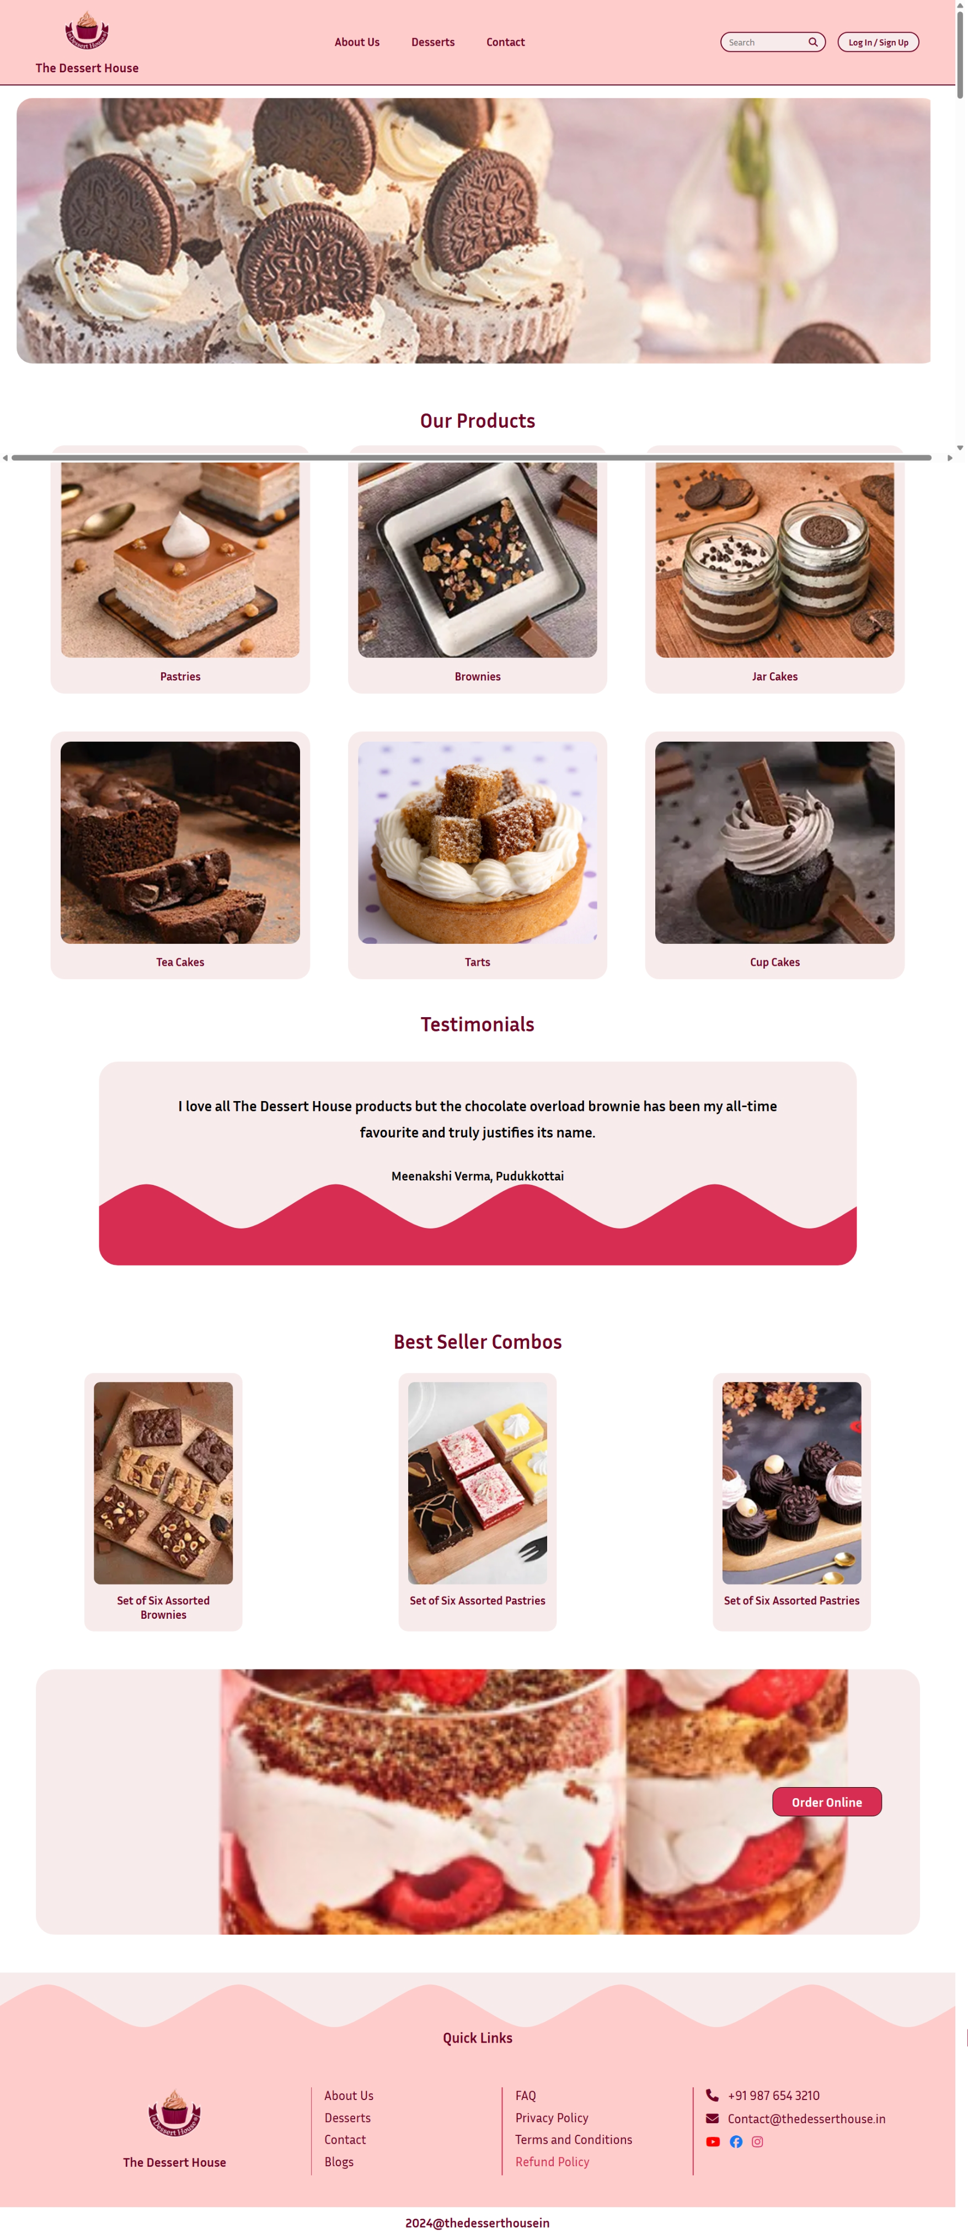

Aboutus page:

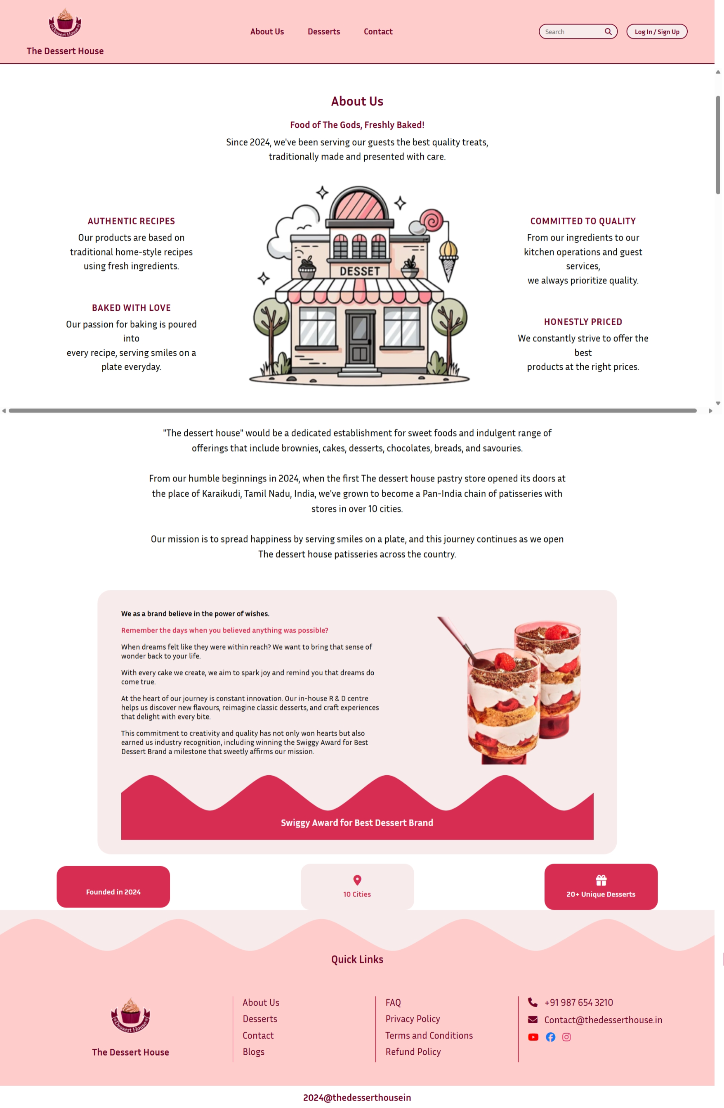

# Contact page:

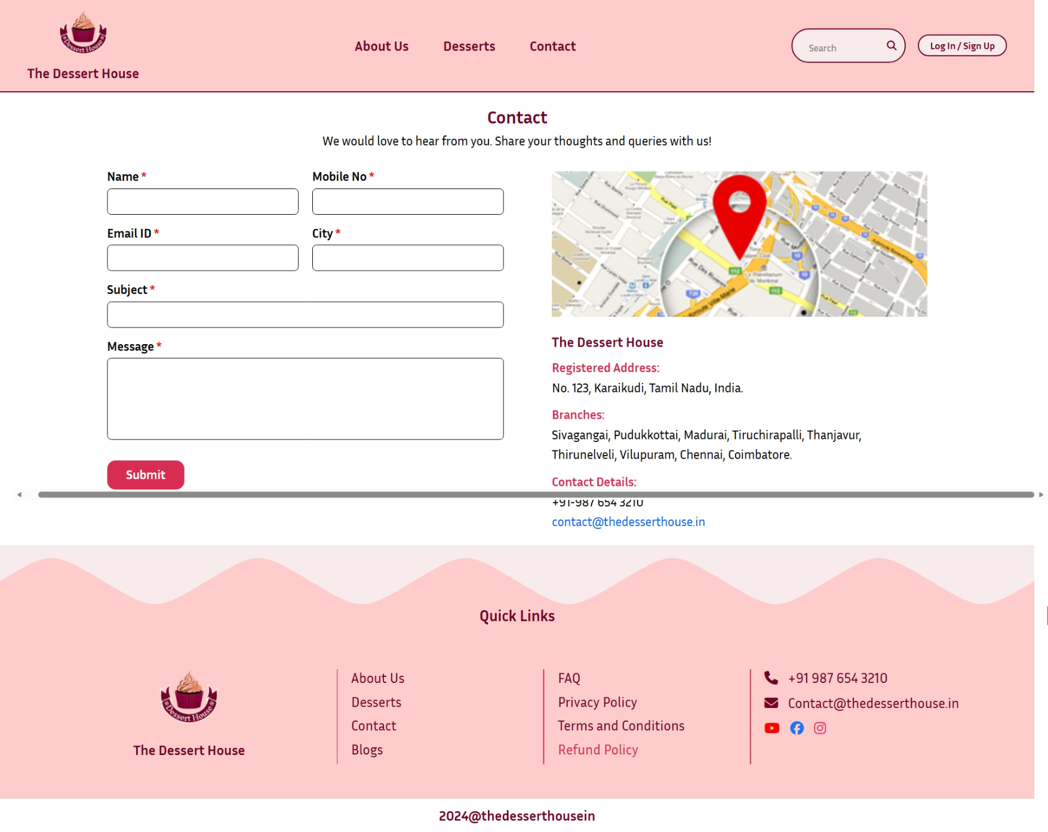

# Conclusion

The Dessert Shop project demonstrates the design and deployment of a modern e-commerce frontend application. The project showcases skills in HTML, CSS, and JavaScript, along with responsive design and UI/UX principles.

The website is ready for future enhancements including backend integration, payment systems, and order management. This project reflects practical frontend development expertise and readiness for real-world e-commerce applications.